Hyper-threading is a process by which a CPU divides up its physical cores into virtual cores that are treated as if they are actually physical cores by the operating system. These virtual cores are also called threads. Most of Intel's CPUs with 2 cores use this process to create 4 threads or 4 virtual cores.

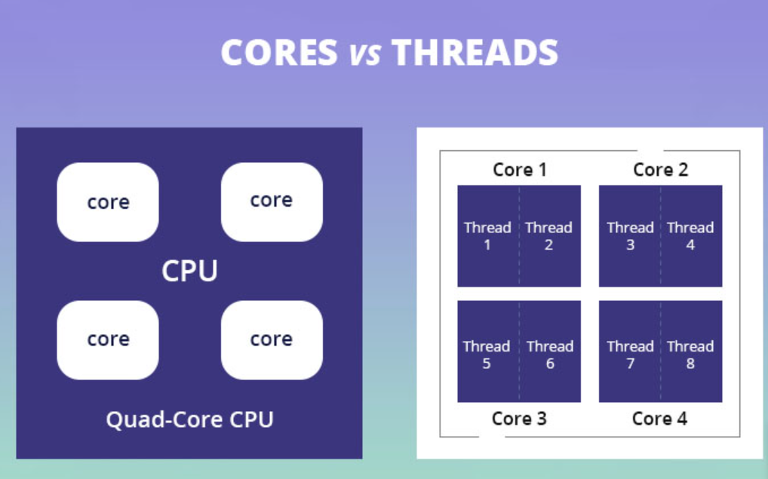

**Single Core Vs Multicore Processor**

First, we need to clarify the difference between a single-core CPU and a multicore processer? Simply put, a single-core CPU will only be able to process one program at a time. However, when you run multiple programs simultaneously, then a single-core processor will divide all programs into small pieces and concurrently execute with time slicing, as you can view in the picture given below.

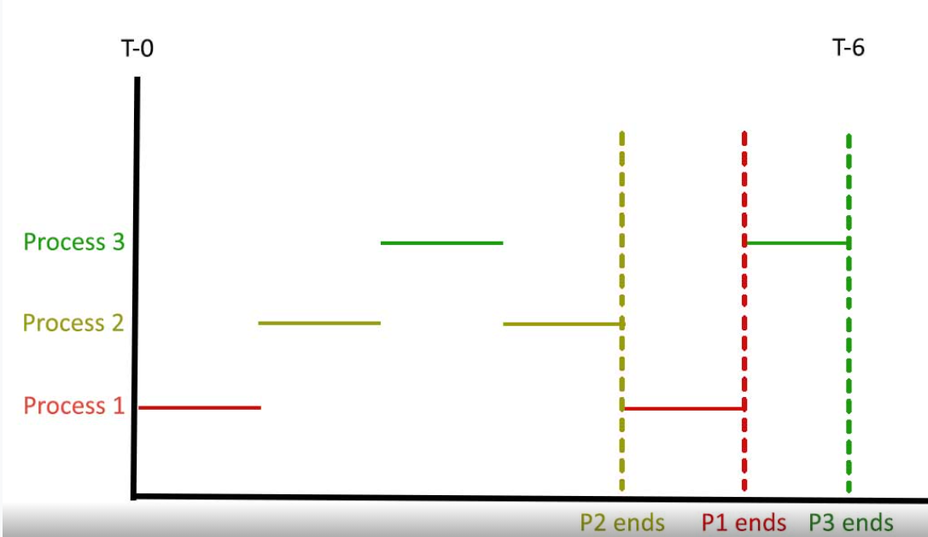

Unlike single-core processing, it is a way in which computing tasks are divided into sub-parts, and a multicore processor (multiple CPU cores) execute each sub-task simultaneously, as you can see in the picture given below:

It is also known as parallel execution because all of the sub-tasks are executing in parallel, and it is how many tasks can be processed at the same time. All modern processors used for commercial purposes must have multicore processors to complete the tasks within a shorter time.

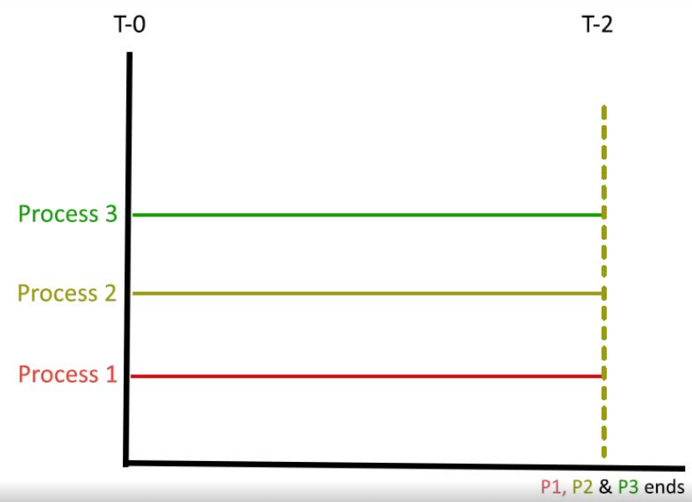

## ****Thread vs Multi Thread****

Thread is a single sequential flow of control in a program that allows multiple activities within a single process.

In simple words, a single thread is like one command that runs at a time.

Most processor manufacturers use the Simultaneous multithreading (SMT) technique to make sure a single processer can run multiple threads. Multithreading is similar to multitasking in which multiple threads are executed at a time, and a multithread ability manages numerous requests by the same user without opening multiple copies of programs running on the computer.

<https://www.intel.com/content/www/us/en/processors/processor-numbers.html>

